What’s happening at Checkendon Pre-school:
Look what we have been doing….

The children have been busy little bees, working hard on creating some lovely art for Mother’s Day. They have been drawing some wonderful pictures and thinking hard about what their mummies like best and incorporating this into their art work. We were all really pleased to welcome our mummies in for the afternoon to join us for our Mother’s Day Diddi Dance. Which was a great success!
We have enjoyed dressing up as our favourite characters from well-loved stories for World Book Day this year, reading some of our favourite stories and re-enacting stories such as the Gruffalo and the little red hen using our wonderful hand knitted story boxes.
As Easter fast approaches the children have been busy with Easter craft, creating Easter baskets and making Easter treats in our Little Chefs sessions as well as having fun with some Easter egg hunts indoors, through the woods, park and local area. The children were also very lucky to receive a visit from the Easter Bunny!

To find out more about Checkendon Pre-School, do visit our website www.checkendonpreschool.co.uk, call us on 01491 682589, e-mail preschoolcheckendon@gmail.com or just pop in – we always look forward to welcoming you to Checkendon Pre-School.
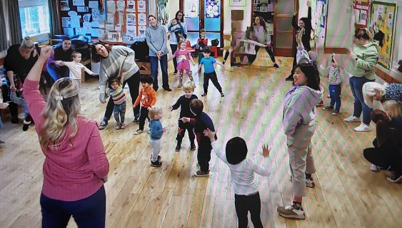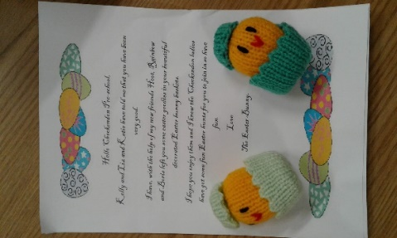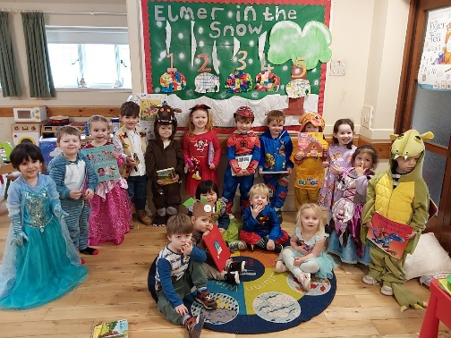
Easter Bunny
Mother’s Day Diddi Dance

1
1
World Book Day
All Enquiries please contact: preschoolcheckendon@gmail.com, Tel: 01491 682589 www.checkendonpreschool.co.uk
Ways you can support Checkendon Pre-School
Easy fundraising. Please support the Pre-School and sign up to raise funds for the Pre-School - https://www.easyfundraising.org.uk/causes/checkendonpreschool/

