What’s happening at Checkendon Pre-school:
Look what we have been doing….

We are all looking forward to celebrating Christmas this year.
This week the children were very excited as they had the arrival of their Christmas post box. This came by Special Delivery Airmail from no other than Rudolf the reindeer! The children have written their letters to Father Christmas and were delighted to post them in their post box and were very pleased when Rudolf took these letters straight to the North Pole.
We have also been decorating Christmas crackers, which may have a little treat inside for the children. The children have also been enjoying the role play area, Fathers Christmas’s Grotto, where the children can wrap presents at the wrapping station, write and send Christmas cards and dress up in lots of festive outfits. We will be celebrating and enjoying many fun activities such as singing, Christmas jumper days and our Christmas party, which the children look forward to every year, and we will be expecting a visit from Jester Giggles and Father Christmas!
The children will also be performing their Traditional Nativity play to all our friends and family. The tickets for Christmas Hamper Raffle are on sale now! If you would like to get your tickets, please visit the ladies at the village hall. The raffle will be drawn on Friday 8th December. Thank you all for your continued support and Merry Christmas!
To find out more about Checkendon Pre-School, do visit our website www.checkendonpreschool.co.uk, call us on 01491 682589, e-mail preschoolcheckendon@gmail.com or just pop in – we always look forward to welcoming you to Checkendon Pre-School.
Reindeer Mail
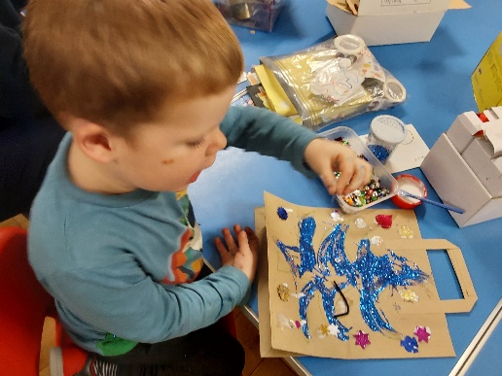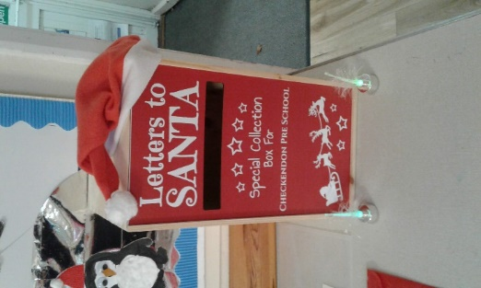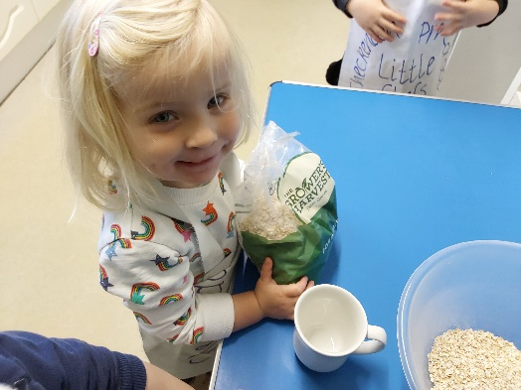
Christmas treats
Christmas Craft
1
1

All Enquiries please contact: preschoolcheckendon@gmail.com, Tel: 01491 682589 www.checkendonpreschool.co.uk
Ways you can support Checkendon Pre-School
We have now signed up for Amazon smile. This means that each time you shop using amazon you can raise some funds for Checkendon Pre-school. Please follow the link https://smile.amazon.co.uk/ch/1156803-0
Easy fundraising. Please support the Pre-School and sign up to raise funds for the Pre-School - https://www.easyfundraising.org.uk/causes/checkendonpreschool/

