What’s happening at Checkendon Pre-school:
Look what we have been doing….

Happy New Year! We would like to wish you all a prosperous 2024!
Checkendon Pre-School is now refreshed and ready to start our new term.
The children this term will be focusing on one of our favourite well-loved books ‘Elmer in the Snow’. We will be investigating, exploring and learning all about Elmer, colours, friendships, uniqueness and cold weather, introducing new vocabulary relating to Winter and the story; what we need to wear to keep us warm and practising putting on items of clothing independently.
We will also be following the children’s interests and learning about a variety of different seasonal celebrations.
Thank you to everyone who has supported us and donated prizes and brought tickets for our Christmas Hamper raffle fund raiser. This was great success!!! The total raised along with teas and coffees brought on the day of our raffle, made a total of £400.00, which is a wonderful total. So, thank you very much! With the money raised we have been able to purchase new Paw Patrol small world resources, which the children are delighted with and will provide hours of fun!!!
www.checkendonpreschool.co.uk, call us on 01491 682589, e-mail preschoolcheckendon@gmail.com or just pop in – we always look forward to welcoming you to Checkendon Pre-School.

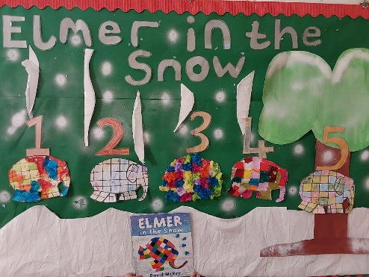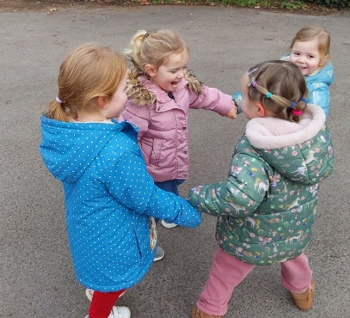
Story time
Outdoor Games
Diddi Dance
1
1

All Enquiries please contact: preschoolcheckendon@gmail.com, Tel: 01491 682589 www.checkendonpreschool.co.uk
Ways you can support Checkendon Pre-School
We have now signed up for Amazon smile. This means that each time you shop using amazon you can raise some funds for Checkendon Pre-school. Please follow the link https://smile.amazon.co.uk/ch/1156803-0
Easy fundraising. Please support the Pre-School and sign up to raise funds for the Pre-School - https://www.easyfundraising.org.uk/causes/checkendonpreschool/

