What’s happening at Checkendon Pre-school:
Look what we have been doing….

We have been making the most of the lovely weather enjoying lots of time outdoors, exploring the world around us. We have been planting lots of exciting things for our flower beds, learning about how things grow and what they need. We have also been planting our very own sunflowers for our dads for Father’s Day. We were all very excited about our end of year trip to Smelly Wellies, where the children were delighted in meeting all the animals with the opportunity to feed, groom, walk and cuddle some of them too!
We still have lots to look forward to in the coming term with the children’s favourite activity….. Sports Day, where the children will partake in some well-loved races. Followed by our traditional family picnic on the field, Leavers Celebrations, end of term Diddi Dance party to name a few. We would like to thank everyone who have helped us over the coming year and appreciate your ongoing and continous support. Thankyou.
We hope you all have a lovely summer and look forward to the new school year and what it will bring!
To find out more about Checkendon Pre-School, do visit our website www.checkendonpreschool.co.uk, call us on 01491 682589, e-mail preschoolcheckendon@gmail.com or just pop in – we always look forward to welcoming you to Checkendon Pre-School.

All Enquiries please contact: preschoolcheckendon@gmail.com, Tel: 01491 682589 www.checkendonpreschool.co.uk
Ways you can support Checkendon Pre-School
Easy fundraising. Please support the Pre-School and sign up to raise funds for the Pre-School - https://www.easyfundraising.org.uk/causes/checkendonpreschool/

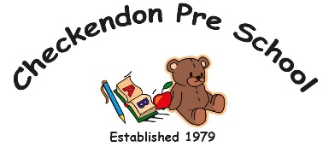
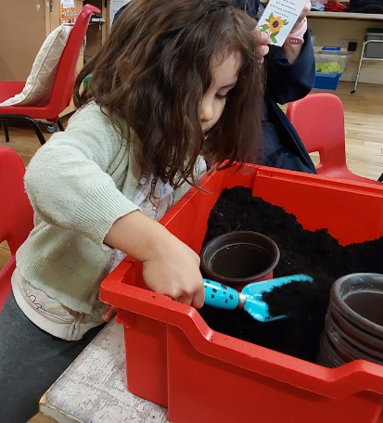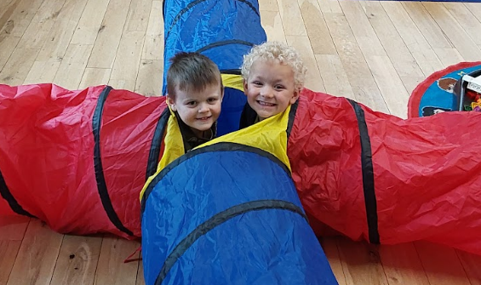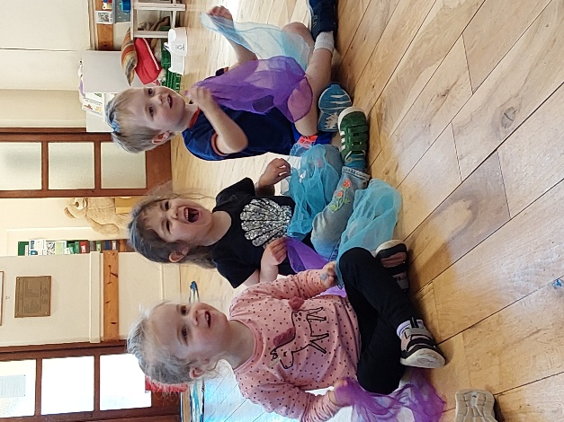
Exploring

1
1
Sunflowers
Diddi Dance

