What’s happening at Checkendon Pre-school:
Look what we have been doing….

We have been enjoying the outside exploring all the new things that have been appearing as we come into spring. Noticing all the details in our local community. Seeing trees start to blossom and exploring new leaves starting to bud and the flowers appearing. Enjoying playing favourite games in the sunshine such as Duck Duck Goose and What’s the time Mr Wolf.
The children have been joining in with Wheels week, bringing in bikes, scooters, and ride-a-longs to Pre-School. This encourages the children to negotiate space, support balance and co-ordination as well as a great way to introduce them to road safety. Wheels week is always a children’s favourite.
This term will see the start of our Transformers. Transformers is our way of supporting and preparing the children, getting them ready for their transition from Pre-School to Primary school. We will be focusing on a variety of activities which will help with their transitions from Pre-School to Primary School.
To find out more about Checkendon Pre-School, do visit our website www.checkendonpreschool.co.uk, call us on 01491 682589, e-mail preschoolcheckendon@gmail.com or just pop in – we always look forward to welcoming you to Checkendon Pre-School.

All Enquiries please contact: preschoolcheckendon@gmail.com, Tel: 01491 682589 www.checkendonpreschool.co.uk
Ways you can support Checkendon Pre-School
Easy fundraising. Please support the Pre-School and sign up to raise funds for the Pre-School - https://www.easyfundraising.org.uk/causes/checkendonpreschool/
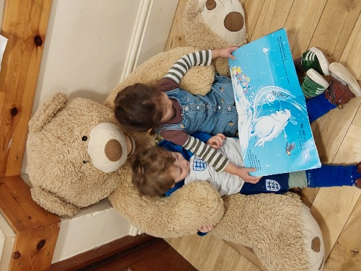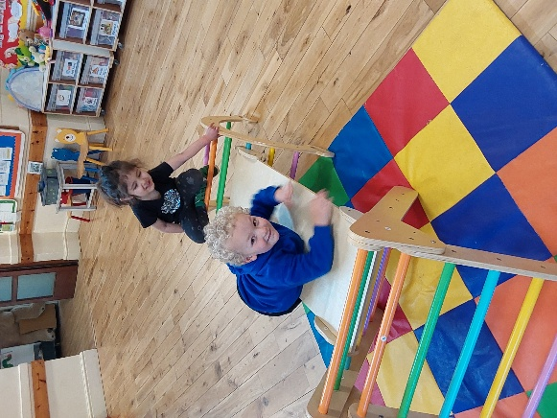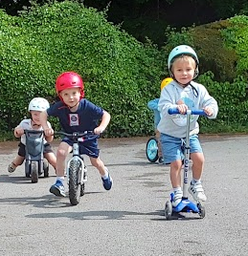
Story time

1
1
Climbing
Bike Week

