What’s happening at Checkendon Pre-school:
Look what we have been doing….

We are delighted to be back after the summer holidays and are looking forward to a fun packed term full of enthusiasm, creativity, and learning. Checkendon Pre-School have had a wonderful start to the new term, settling in to our new routines, exploring, learning, having fun as well as meeting new friends and reuniting with old ones. We would like to welcome our new children Florence, Nicholas, Finn and Ethan to Checkendon Pre-School.
This term we will be focusing on children’s “Interests”. As well as our book of the term ‘Stick Man’ which we hope will inspire and engage children’s learning through play. Focusing on children’s interests is an excellent way for the children to get to know each other and encourage a variety of different activities and learning.
Checkendon Pre-School will be encouraging the children to be independent, helping, and encouraging them to learn skills through their everyday routines such as making decisions and taking on responsibility.
We are also celebrating Harvest, baking bread, reading the Little Red Hen and talking about how crops grow. We are also looking forward to celebrating upcoming seasonal celebrations such as Halloween, Rosh Hashanah and Bonfire night.
To find out more about Checkendon Pre-School, do visit our website www.checkendonpreschool.co.uk, call us on 01491 682589, e-mail preschoolcheckendon@gmail.com or just pop in – we always look forward to welcoming you to Checkendon Pre-School.

All Enquiries please contact: preschoolcheckendon@gmail.com, Tel: 01491 682589 www.checkendonpreschool.co.uk
Ways you can support Checkendon Pre-School
Easy fundraising. Please support the Pre-School and sign up to raise funds for the Pre-School - https://www.easyfundraising.org.uk/causes/checkendonpreschool/

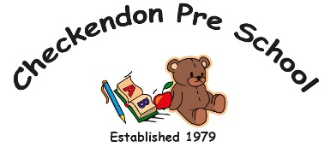
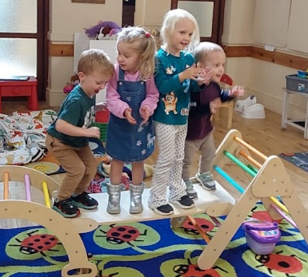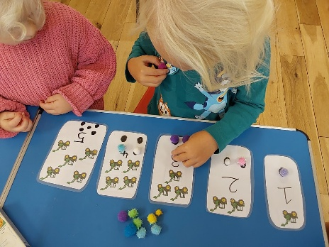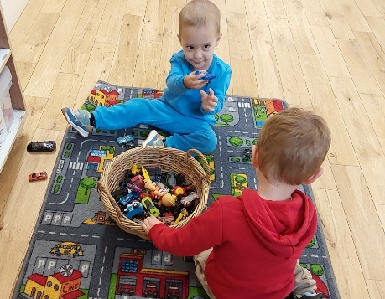
Playing & exploring
Singing & Dancing
Harvest counting

1
1

